Project Report

COMS 4901 – Projects in Computer Science
Summer 2009

Jonathan Bell

Prepared for:
Prof Gail Kaiser
Mr Swapneel Sheth
Originally submitted 8/27/09
Revised 9/15/09
Revised 12/16/09

Background 3
genSpace 3
CPU Torrent 3
Requirements 3
genSpace 3
CPU Torrent 4
Design and Implementation 4
genSpace 4
CPUTorrent 8
Supported user stories (genSpace) 8
Results (CPUTorrent) 10
Recommendations for Future Work 13
genSpace 13
CPUTorrent 13

Background

genSpace

geWorkbench is a Java‐based open‐source platform used by genomic researchers across the world. genSpace is a research project at the Programming Systems Laboratory at
Columbia University that aims to experiment in building social‐networking oriented
collaboration features into the existing geWorkbench application. Currently, genSpace’s
primary function is identifying workflow patterns and providing real‐time suggestions
and support.

CPU Torrent

CPUTorrent is a research project aimed at studying the mass‐distribution of
computationally complex jobs. While some jobs require “proprietary” systems requiring
specially licensed software, others may be simple compute jobs that just require a
powerful computer. CPUTorrent is a system to automatically divide these jobs.

Requirements

genSpace

jClaim, a Java-based AIM client was built into genSpace by a previous project student. It provides basic instant messaging capabilities between users, but is cumbersome and requires users to have AIM accounts, and to log into these accounts separately. I set out to create a new messaging infrastructure that accomplished the following goals:
1 – Provide seamless integration with genSpace
2 – Support transporting high-level objects
3 – Provide, minimally, the ability to message another user the current workflow.

An additional goal was added mid-project: to be able to share screens with other users.

The following “user stories” were considered:

(1) Logging In
Users will log into genSpace chat by logging into genSpace. The users’s genSpace username will serve as the chat username, and the user’s genSpace password will serve as the password.

(2) Buddy List
Once logged in, users will be presented with a “buddy list” – a roster of users who are in the same lab. The buddy list window will also allow users to set their “status” to available, busy, or offline. The roster will identify users as available, busy, or offline by using different colors for each status.

(3) Creating Chats
A chat can be initiated by double clicking a user’s entry in the buddy list. Once a message is sent, a chat is created on the receiving user’s computer as well. Closing the chat window will end the chat only on that computer – the other chat participant will not be notified that the first user left the chat.

CPU Torrent
A significant pen-and-paper analysis has been performed to try to understand CPU Torrent’s usefulness in real situations. However, it has been difficult to gather compelling data to support further research. Therefore, I planned to create a simulation of what could be typical compute jobs, processed in what could be a typical fashion.

The simulator will encompass both sides of the process: submitting jobs and processing them. It will create simulated job loads, and then run those loads against simulated job processors. The job loader will be configurable to generate different distributions of jobs in order to simulate different job loads. Similarly, the job processor must complete jobs deterministically, yet be configurable.

Design and Implementation

genSpace

I have created a fully integrated XMPP based chat client within genSpace by leveraging the Smack XMPP stack (http://www.igniterealtime.org/projects/smack/), and the Tigase XMPP server (http://www.tigase.org/). The chat client is integrated to login by the user whenever the user logs into genSpace, using the same credentials that he or she enters to log into genSpace. Authorization by the XMPP server is sourced from the same SQLServer database that genSpace gets login information from.
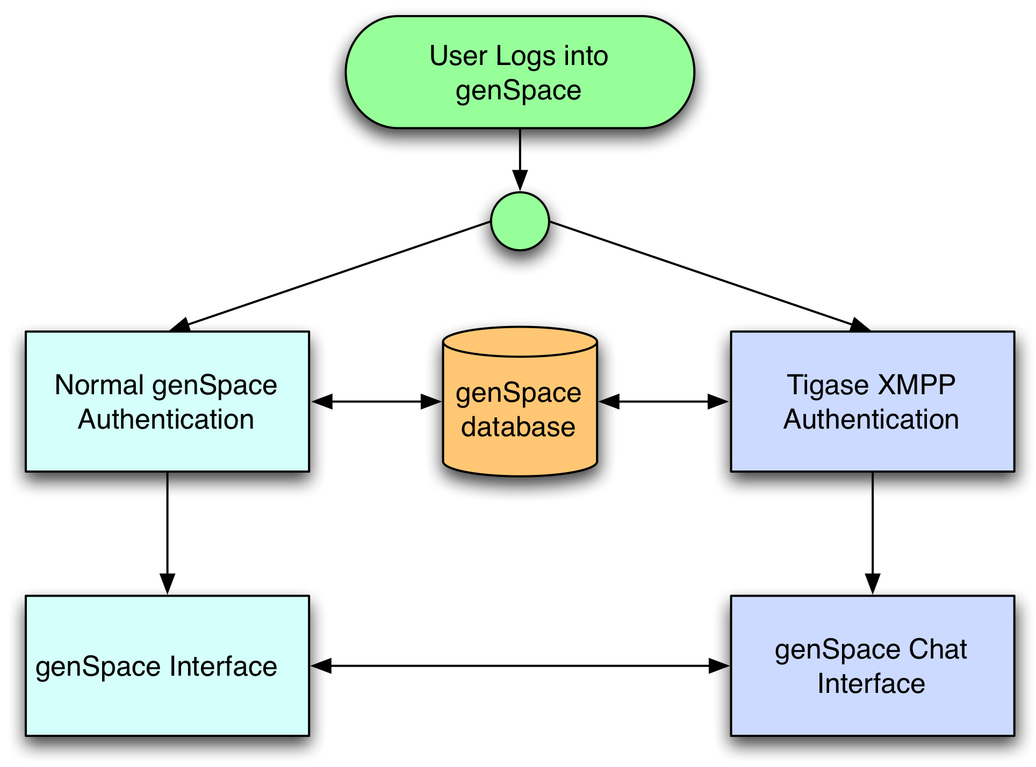

This is implemented as a custom authentication connector in the Tigase configuration. The server is installed in /opt/tigase on lenox.cs, and the special configutration in init.properties is specified below:
basic-conf/auth-repo-params/conn-valid-query=select 1
basic-conf/auth-repo-params/init-db-query=update registration set online_status = 0
basic-conf/auth-repo-params/user-login-query={ call TigUserLoginPlainPw(?,?) }
basic_conf/auth-repo-params/user-logout-query=update registration set online_status = online_status - 1 where username = ?
basic-conf/auth-repo-params/sasl-mechs=PLAIN
basic-conf/auth-repo-params/non-sasl-mechs=password
basic-conf/auth-repo-params/users-domain-count-query=select count(*) from registration where username = ?

By using a unified authentication database, I eliminated the problem of multiple logins.

Chat features are implemented on top of the Smack XMPP client. Class relationships are detailed in the UML diagrams that follow. ChatReceiver is the singleton class that manages all high-level chat functions: logging in, and creating chats. It maintains a collection of ChatWindows, each of which both represent a chatting window on the screen and a specific chat connection to a user. The RosterFrame contains all roster and presence (available/away/offline) information, and the RosterPanel contains the roster specifically, allowing you to create chats directly with available users.

The ScreenSharePublisher and ScreenShareListener work with the Apache MINA (http://mina.apache.org/) libraries to send and receive screen captures. Screen sharing is explained in detail later in this section.

Rosters are currently manually set through the Smack API (there is no UI for adding friends). Ideally, the chat rosters would be dynamically maintained from groups/networks established in genSpace. This would be a trivial feature to add once networks and groups are firmly built into genSpace.

Messages have types, which signal the receiver that the message is special, for instance, it may contain a workflow that needs to be visualized, or it may contain handshake information for setting up a direct connection.

Screen sharing is supported over a direct TCP connection, established with a handshake over the existing XMPP connection. Screen captures are taken at approximately 10fps, and are split into 32x32 pixel tiles, then each updated tile is compressed and sent over the stream to be decompressed and placed into its spot. A table of tile hashes is maintained on the machine sending the screen so that it can restrict sent tiles to updated tiles only. This is very similar to standard “hextile” encoding, where the screen is split into 16x16 pixel tiles, with only a modification of tile size. In my tests, it was easier to send more bigger packets than to send a lot of small pixels – there is a tradeoff between improvements in processing time and transmission time. The frames were originally transmitted over the XMPP connection itself, but it proved too laggy and inefficient to process the high rate of relatively large packets. A diagram of the process follows:
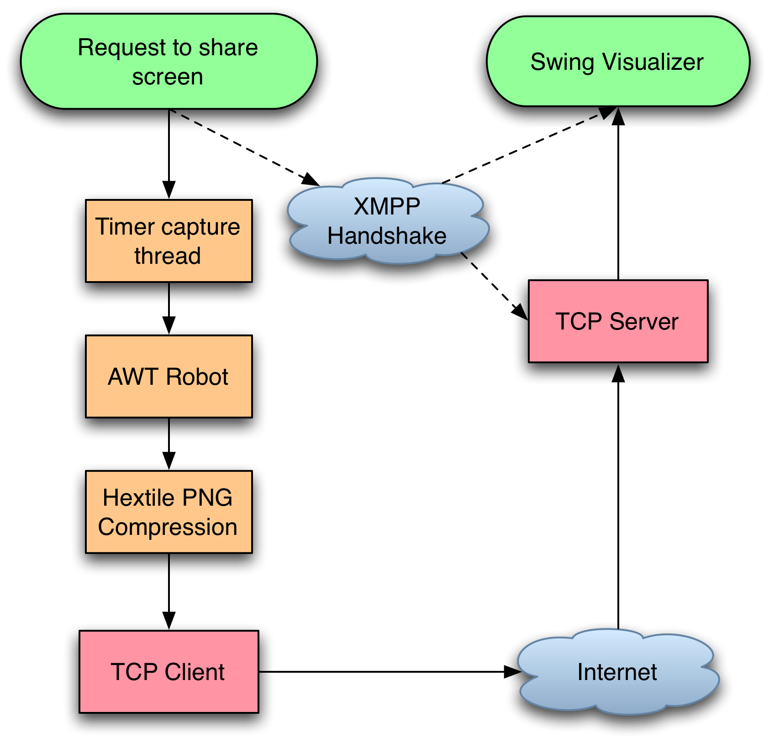

CPUTorrent

In order to understand the real-world gains from the CPU Torrent system, I created two simulators: one to create job loads (as theoretical users), and one to process them (as theoretical remote processors). The simulator models the complete CPU Torrent system - clients submitting jobs, CPU Torrent dividing the jobs between providers, and processing these jobs. I ran the simulators with two different job processors: a slow “proprietary” provider, and a much faster “utility” provider. I varied α, the percentage of jobs being offloaded from the proprietary to the utility provider, and analyzed the overall reduction in user wait times.

I modeled the processing time of jobs as an exponential distribution, picking job lengths randomly from the distribution. I utilized two distributions: one for the utility and one for the proprietary provider. The utility provider’s distribution was centered at 2 seconds, and the proprietary provider’s distribution was centered at 8 seconds. The distributions were both generated once, and then reused for each test with a different α - each test utilized the same job length distribution so that they could be directly compared. Similarly, I modeled the incoming jobs as Poisson arrivals with a mean centered at 2 jobs/seconds. This allowed me to complete the simulation in a reasonable amount of time (hours instead of weeks), and with the corresponding job length time, was able to saturate the queue without overwhelming it. I also modeled incoming jobs as a Gaussian distribution and as an exponential distribution.

User Stories as Implemented (genSpace)
Upon logging in (Story 1/not shown), users are presented with a simple roster (Story 2)
Users can change their status, see the status of other users (by either the green/red/grey for available/busy/offline or by hovering the mouse over the user), and initiate chats. To initiate a chat, the user double clicks on a buddy (Story 3). Once a chat is initiated, the user can have a text conversation, share their screen (only the part containing the geWorkbench window, and only “read only” – there is no cursor control), or send the current workflow.

Results (CPUTorrent)

I scaled the number of nodes down to be closer to the number of CPUs on the testing machine (m = 2 for each service). I ran the entire simulation on an Apple Mac- book Pro with 2 2.8 Ghz cores, 4 GB of RAM, Mac OS 10.6.1, and Java 1.5.0 19, with no non-system processes running. I ran the simulator with 5 different configura- tions, varying the percent of jobs offloaded from the pro- prietary provider to the utility provider from 0 to 1, in in- crements of 0.25. Each configuration ran for 10 minutes, sequentially on the same machine.

Figure 1 below shows the total time for a job as the jobs are executed, with poisson arrivals. Each series represents a different value of α, the percent of jobs that are offloaded, ranging from 0.25 to 1. The series with α = 0 represents the case where there is no offloading and CPU Torrent is not used.

When CPU Torrent is not used, the total time for a job increases in a roughly linear pattern. This is because a job has to wait in the queue for a longer period of time for previous jobs to finish processing. With CPU Torrent, for the different values of α, the total time for a job remains roughly constant and this constant varies with the value of α. Further, we notice that for values of α greater than 0.25, the total time taken is roughly the same. Since we modeled only one utility service provider, it started getting saturated with job requests resulting in degradation of the time improvement.
Finally, we observe that even for smaller values of α such as 0.25, there is a significant reduction in the user wait time for a job.
Figure 1 - User wait time Reduction – Poisson Arrivals
In figure 2 below, I used a Gaussian distribution with a mean at 2 jobs/second (std deviation=1 job/second). The results are very similar.
Figure 2 - User wait time reduction – Gaussian Arrivals

Figure 3 below shows the same simulation running, but with exponential arrivals. The jobs arrival distribution was centered at 2 jobs/second. Again, the results are similar: there are significant improvements when using CPUTorrent.
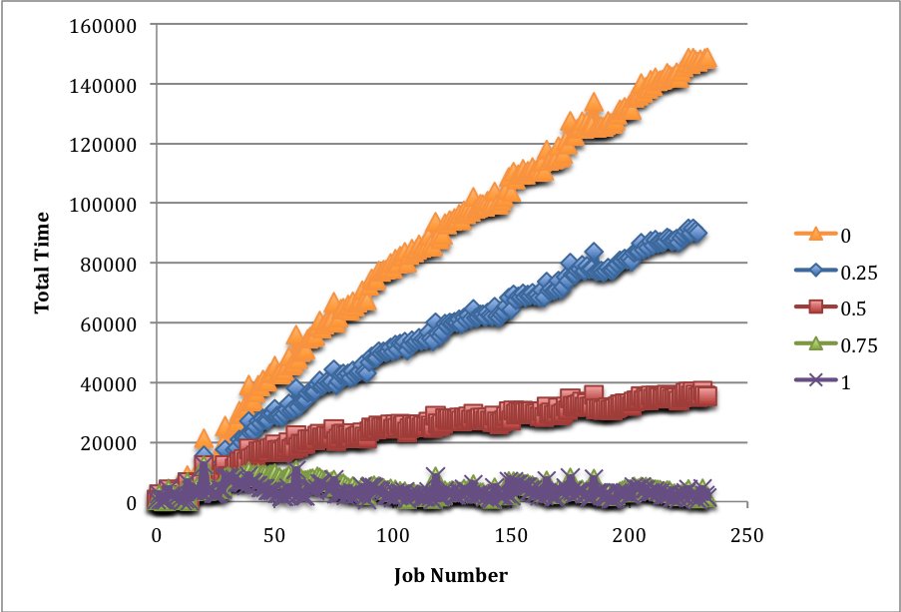
Figure 3 – User wait time reduction - Exponential Distribution

Recommendations for Future Work

genSpace

The chat features are mostly solid, but could use a little fine tuning. For example, it would be nice for rosters to be automatically created based upon social networks. It was also suggested that there be a feature to save chats to the website. Another helpful feature would allow screen sharing users to mark up the screen with boxes and arrows. None of these features are particularly novel to the field, however, and I would suggest that care is taken in further developing these features before understanding how used they are.

CPUTorrent

CPUTorrent is at an interesting position: it is clear that it will provide a substantial improvement in job processing time if jobs can be offloaded. Real usage data is needed to draw more concrete conclusions on the potential benefits from CPUTorrent. One way to gather this data is to create a skeleton CPUTorrent that simply inspects jobs and passes them off untouched, simply for data gathering purposes. This, of course, however, requires willing users to participate.

